Report on Cleanliness and Workplace Enhancement Activities
Dasmesh Girls College Chak Alla Baksh Mukerian
State: Punjab
Dates of Activities: (Oct 14-Oct 17 )2025
Submitted By: Department Of Education

1. Various Activities Relating to Cleanliness
As part of the institutional cleanliness drive, a series of activities were conducted to promote hygiene and sanitation across the campus. Students, faculty, and non-teaching staff participated actively.
Key activities included:
- Sweeping and mopping of classrooms, laboratories, and corridors.
- Cleaning of notice boards, furniture, and equipment.
- Installation of dustbins at multiple points to ensure proper waste disposal. Awareness sessions on “Clean Campus, Green Campus” emphasizing personal and environmental hygiene.
2. Review of Record Management System
A comprehensive review of the existing record management system was undertaken to ensure effective organization and retrieval of institutional records.
Activities included:
- Verification and updating of physical and digital files.
- Reorganization of documents in labeled folders and cabinets.
- Digitization of important academic and administrative records.
- Implementation of a systematic indexing method for easy access.
The new management system enhanced efficiency in record handling, minimized duplication, and supported a cleaner, clutter-free office environment.
3. Productive Use of Space
- Unused and underutilized spaces within the institution were identified and repurposed for meaningful use.
- Examples include:
- Conversion of a vacant area into a reading and relaxation corner.
- Beautification of open spaces with indoor plants and artwork.
- Reorganization of storage rooms to maximize space utilization.
4. Disposal of Waste Materials for Enhancing Workplace Experience
Proper segregation and disposal of waste materials were carried out as per eco-friendly guidelines.
Steps taken:
- Separation of biodegradable and non-biodegradable waste.
- Safe disposal of electronic and paper waste through authorized vendors.
- Composting of organic waste in designated pits.
- Conducting a session on “Reduce, Reuse, Recycle” to spread awareness.
5. Adoption of Surrounding Areas for Cleanliness Drive
The institution extended its cleanliness efforts beyond the campus through community outreach.
Actions included:
- Adoption of nearby public areas for a cleanliness drive.
- Collaboration with local municipal bodies and community groups.
- Awareness campaign on sanitation and waste segregation among residents.
- Plantation and beautification of adopted areas.
Conclusion
The coordinated efforts under the cleanliness and workplace enhancement program brought about significant positive changes within and around Dasmesh girls college, Chal Alla Baksh Mukerian. The activities not only improved hygiene and organization but also fostered environmental consciousness and community participation.
Pictures
Waste Management
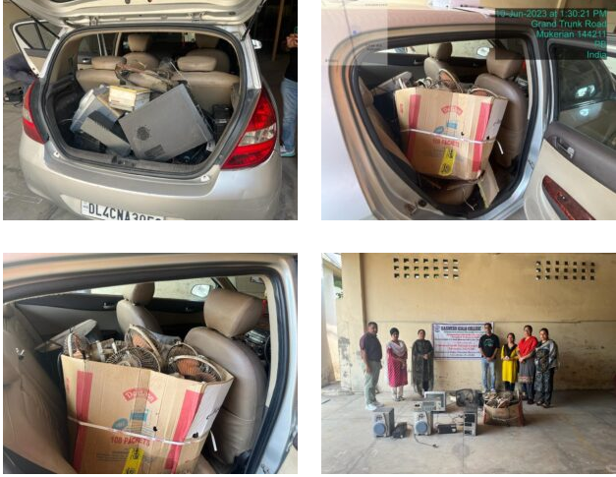
Cleaning of notice boards, furniture, and equipment
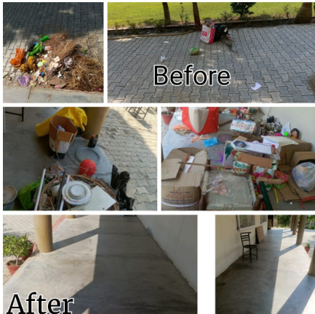
Conversion of a vacant area into a reading and relaxation corner
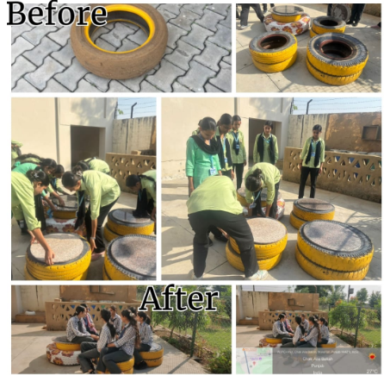

Conducting a session on “Reduce, Reuse, Recycle” to spread awareness.
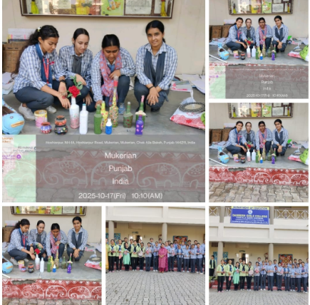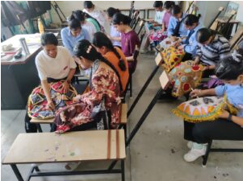
Adoption of Surrounding Areas for Cleanliness Drive
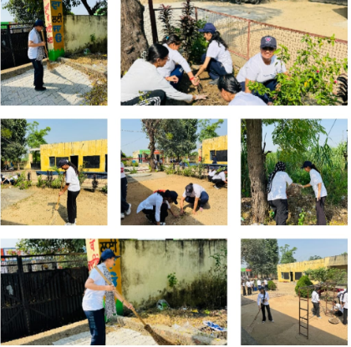
Beautification of open spaces with indoor plants and artwork.
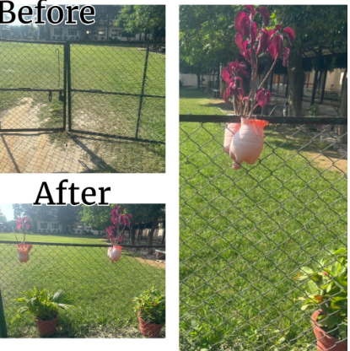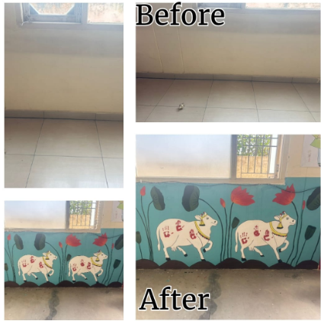
Composting of organic waste in designated pits.

