REPORT ON OBSERVANCE OF THREE-MONTH CAMPAIGN ON PREVENTIVE VIGILANCE AND VIGILANCE AWARENESS WEEK – 2025
Name of the Institution: Dasmesh Girls College
Address: ,Chak Alla Baksh ,Mukerian
Period of Campaign: 18th August 2025 to 17th November 2025
Vigilance Awareness Week: 27th October 2025 to 2nd November 2025
In compliance with the circular issued by the Vigilance Division, NCTE, dated 21.08.2025, the Institute actively participated in the Three-Month Campaign on Preventive Vigilance and Vigilance Awareness Week – 2025 under the theme of promoting integrity, ethics, transparency, and good governance.
The objective of the campaign was to raise awareness among students, faculty, and staff regarding ethical conduct, vigilance, and preventive measures against corruption.

2. Activities Conducted

A. Integrity Pledge and e-Pledge
- All faculty members, non-teaching staff, and students were encouraged to take the e-Pledge available on the CVC website (https://cvc.gov.in
- The Integrity Pledge was administered in the Institute on 27th October 2025 at 11:00 A.M.

B. Awareness and Sensitization Programmes
- Workshops and sensitization sessions were organized for students and staff on the following topics:
  - Preventive Vigilance and Ethics in Public Life
  - Transparency and Accountability in Institutional Functioning
  - Cyber Hygiene and Ethical Use of Technology
- Resource Persons: ,Dr. Akanksha Verma and Ms Pooja
C. Social Media & Publicity Initiatives
- Awareness messages were circulated through email, WhatsApp groups, and Institute’s social media handles.
- The Institute’s social media posts tagged @CVCIndia (X) and CVCofIndia (Facebook) as per the guidelines.

D. Capacity Building Programmes
- Capacity Building Sessions were organized on the following topics:
  - Ethics and Professional Conduct
  - Integrity in Administration
  - Cyber Security and Data Privacy
- Duration: Between 18th August and 17th November 2025

3. Observance of Vigilance Awareness Week (27th October – 2nd November 2025)
During the Vigilance Awareness Week, special programs were conducted, including:
- Conduct seminars by the students on the theme of “My Vision – Corruption Free India”
- Debate and quiz competitions related to ethical values and vigilance.
- Collective Integrity Pledge ceremony for all members of the Institute.
- Screening of short films/documentaries on ethics and integrity.

4. Outcomes and Impact
- Enhanced awareness among students and staff on ethical behavior and vigilance measures.
- Improved understanding of institutional policies and procedures promoting transparency.
- Strengthened institutional commitment toward preventive vigilance and integrity.

5. Conclusion
The Institute successfully implemented all suggested activities during the three-month campaign and Vigilance Awareness Week 2025.
The collective efforts of students, faculty, and staff contributed to fostering a culture of integrity, accountability, and transparency within the institution.

Signature)
Head of Institution / Principal
Name: Dr.Karamjit Kaur
Dasmesh Girls College, Chak Alla Baksh Mukerian

Pictures
Expert’s Session on the topic Cyber Hygiene and Ethical Use of Technology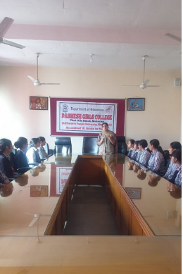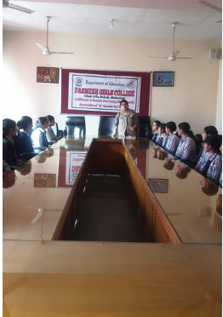
Activity by the Students on Capacity Building
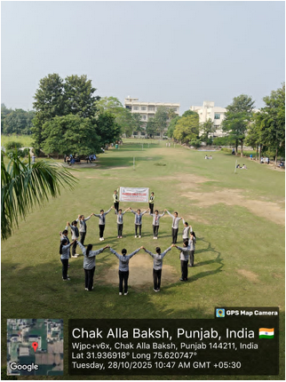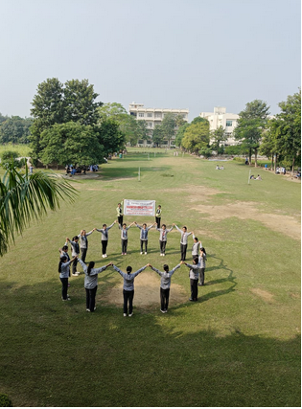
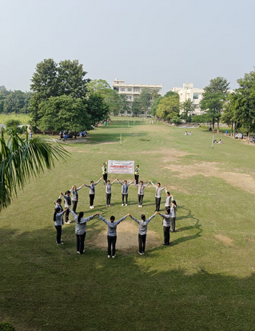
The Integrity Pledge was administered in the Institute
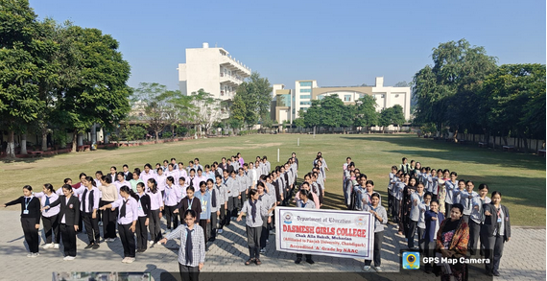

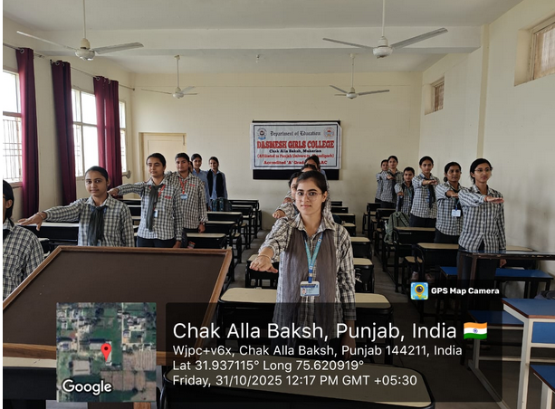

Awareness Programme
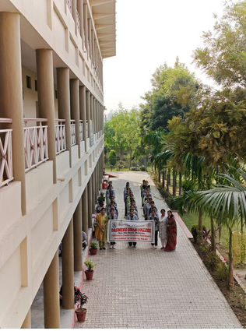
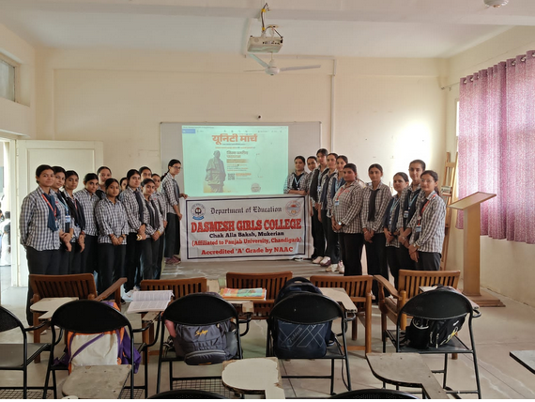
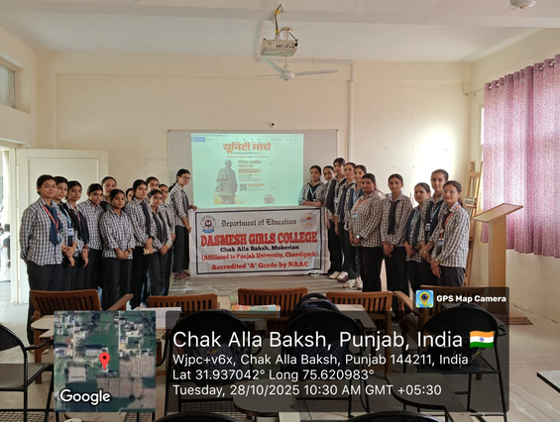

Conduct seminars by the students
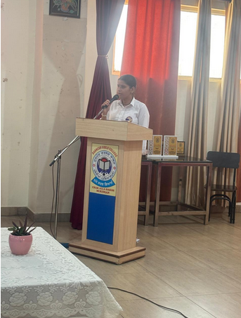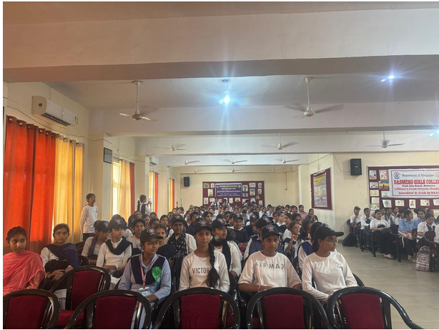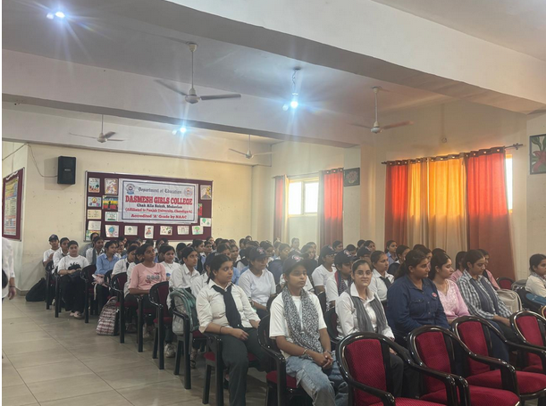

Screening of short films/documentaries on ethics and integrity.
