 **Dasmesh Girls College, Chak Alla Baksh, Mukerian**

**Recognized by UGC under 2(f) & 12(B)**

**Affiliated to Panjab University, Chandigarh**

**Accredited by NAAC**



**ACADEMIC AND ADMINISTRATIVE AUDIT REPORT**

**Session 2018 -23**

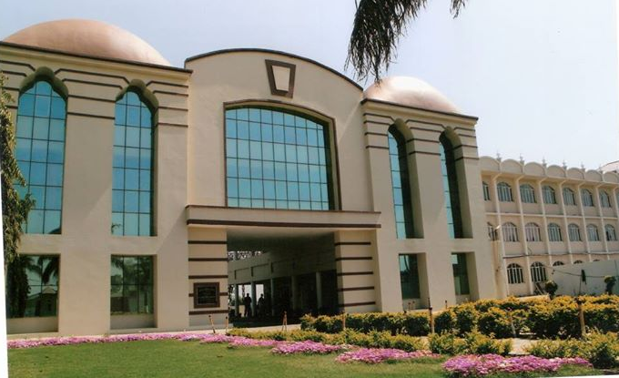

**About the Institution**

**Dasmesh Girls College**, an eternal link in the immortal chain of **Sri Guru Gobind Singh Educational Chatritable Trust, Chak Alla Baksh, Mukerian,** was established in December 2000. It is an institution where learning is a religious habit. It aims at imparting value-based education. This seat of learning has been enunciating the gospels of Guru Gobind Singh in particular and the message of humanity in general. The custodians in the field of education and the great philanthropists of the area got their dream materialized when they came forward with their mission of establishing the institution in the cradle of nature. The growth of the college became phenomenal when they contributed their might along with S. Prakash Singh Badal, the then Chief Minister, who showered his bounteous blessings on it on December 21, 2000. Since then, this institution has inculcated a code of discipline and morality among students. The college combines a commitment to teaching excellence with extensive sports and cultural opportunities. The academic and cultural activities are focused on inculcating a strong sense of commitment to nationalist, i.e., social and aesthetic values. Seminars, workshops, conferences, and exhibitions are regular features of its UG / PG departments. The institution is making every possible effort to uplift the poor and downtrodden sections of the area by educating their women and encouraging them to realize their potential to face the mind-boggling situations of the globalized world. Dasmesh Girls College is housed on a spacious, pollution-free, picturesque, and lush-green campus at a convenient distance from the town. A sense of splendor, beauty, discipline, and academic excellence pervades the corridors of the campus. At present, the college has four-story blocks, viz., Arts and Administrative Block, Mata Gujri Block, Mata Sundri Block, and Bhai Gurdas Block. The college has four sophisticated computer labs, a language lab, Psychology lab, Mathematics lab, a Physics lab, a Chemistry lab, a Zoology lab, a Botany lab, Conference Room, Seminar hall and a smart class room with all the modern infrastructure required for extending quality education to the students. The college library is the lifeblood and soul of this institution. It is fully computerized for various operations, viz., Acquisition of books, cataloging, classification, transaction (issue and return), inquiry, etc. This college is being managed by the experienced members of the committee. Under the innovative leadership of its Principal Dr. (Mrs.) Karamjit Kaur, herself a dazzling luminary in the field of education, this college is marching from strength to strength. The college is progressing by leaps and bounds. The college is **Accredited ‘A’ grade by NAAC,** which has further boosted its credibility in the region. The college has been awarded **Best NSS Unit among the colleges in the state of Punjab**. The college has run NSS, NCC, and the Red Ribbon Club for the betterment of the students.

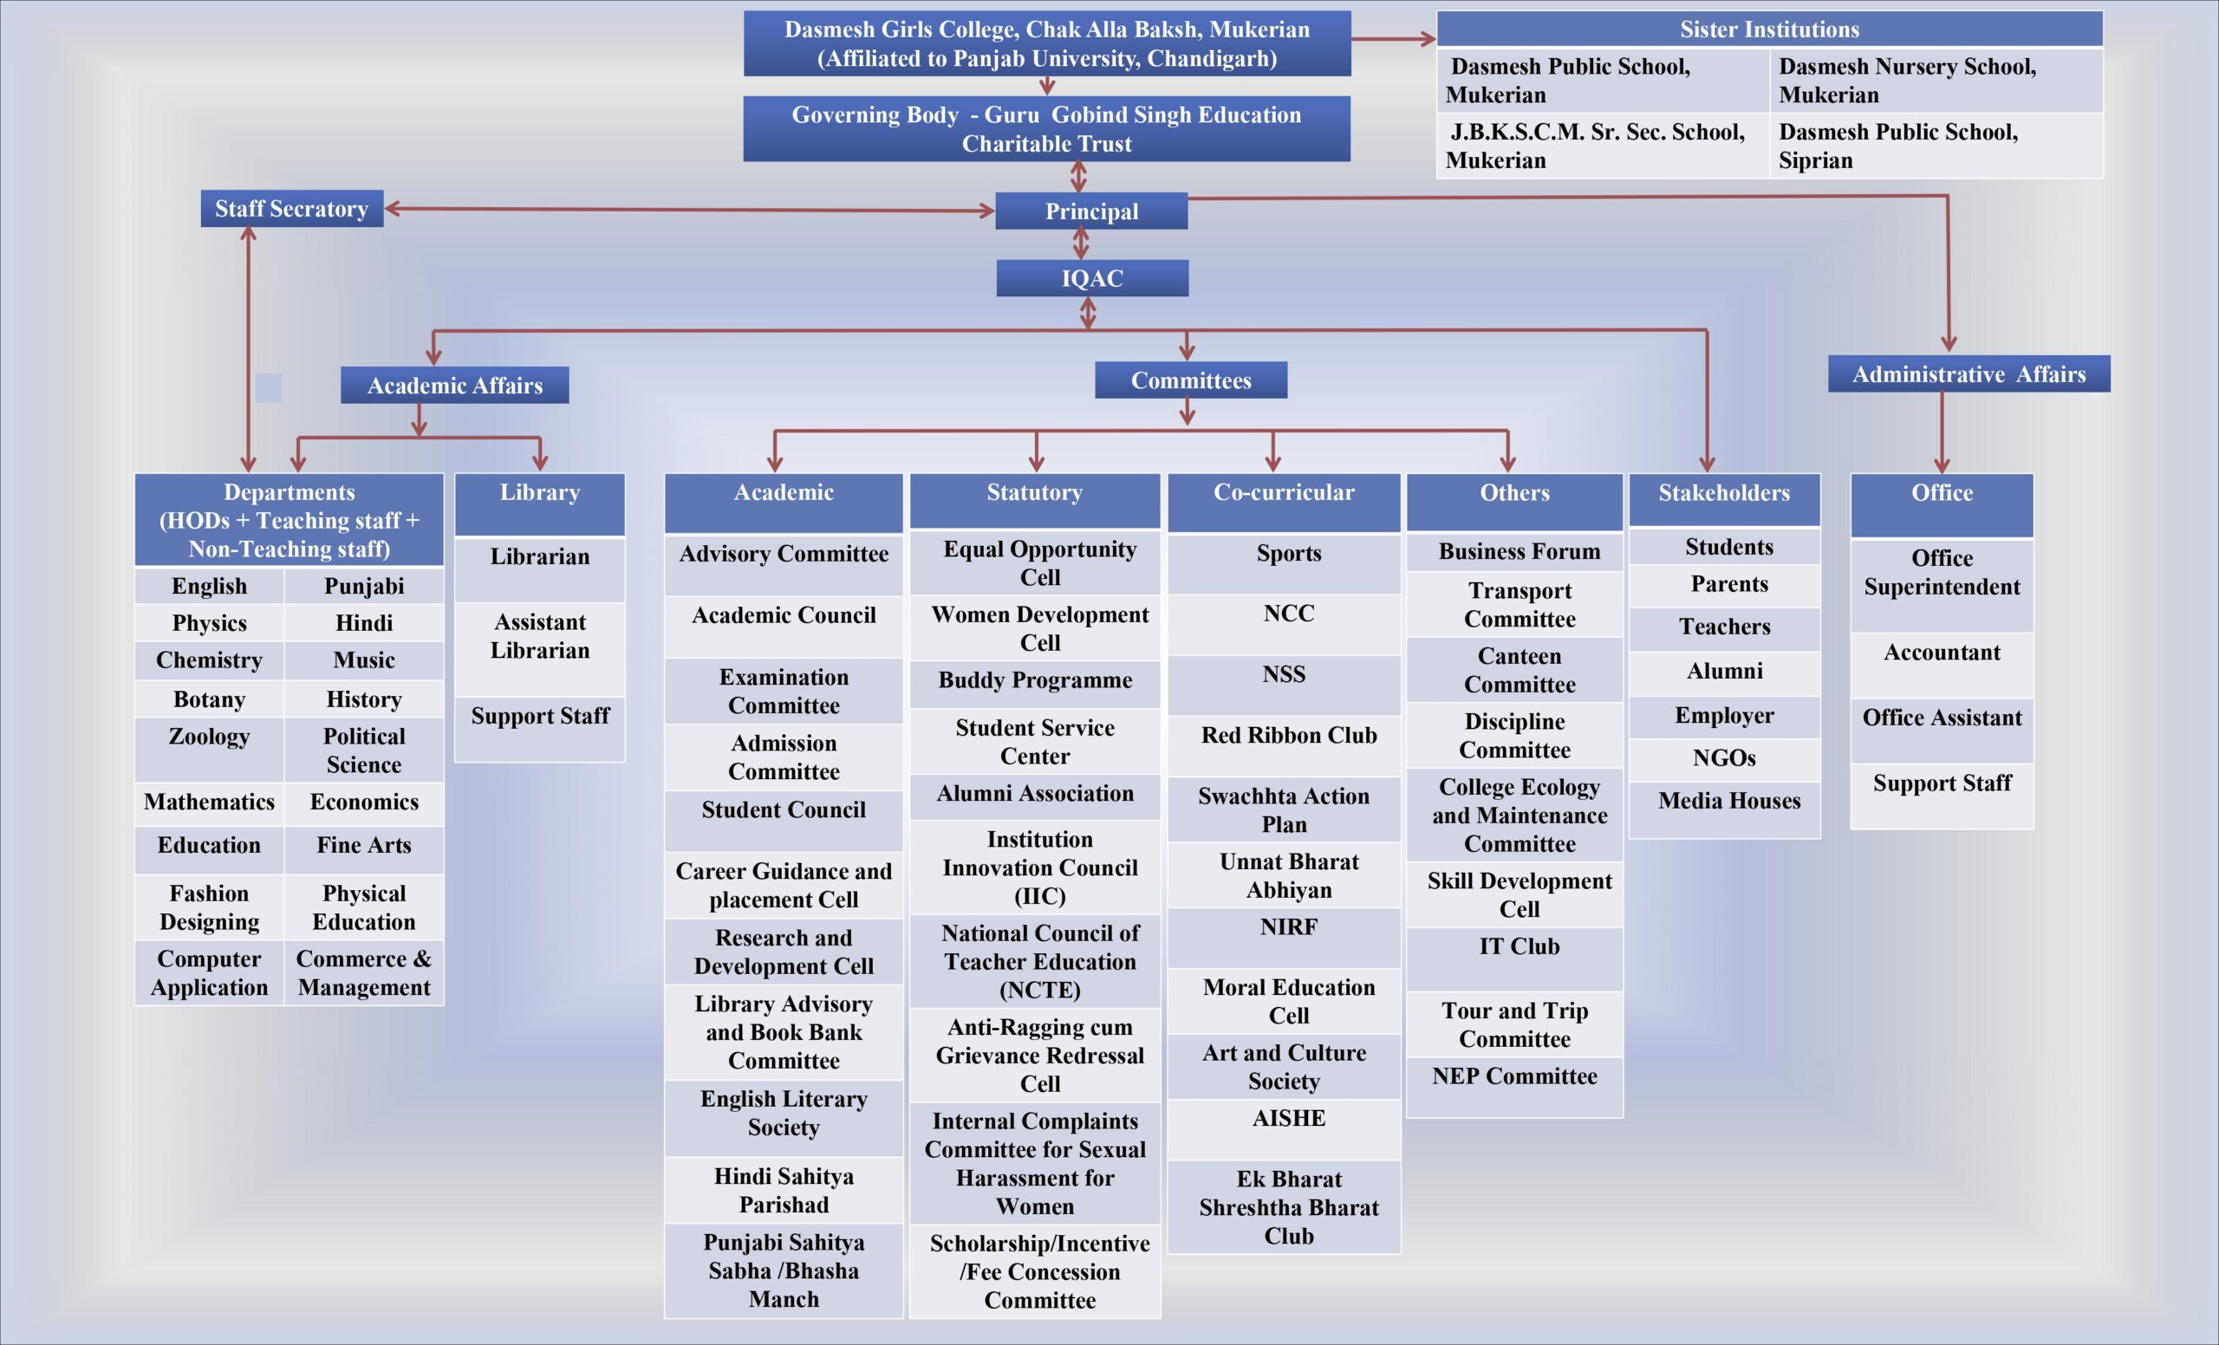

**Vision:**

* To impart value-based education to the students
* To contribute toward the upliftment of the poor and down-trodden of the area by educating the women folk.
* To sensitize students regarding issues of contemporary relevance and guide them to emerge as responsible citizens of society.
* To maintain phenomenal academic standards through effective teaching.
* To engage in the promotion and revival of Indian tradition, culture, heritage and spiritual philosophy.

**Mission:**

• To broaden horizons and enrich the life of women.

• To develop cultural sensitivity and global understanding.

• To make women competent professionals in today's competitive work culture.

• To be in the forefront of the development of a nation.

• To inculcate discipline and culture.

• To enhance employability through innovative methods.

• To inspire the students to imbibe the virtues of hard work, perseverance and to develop a

positive attitude.

**Goals and Objectives**

* To train students with a view to developing their overall personalities.
* To focus on students, to develop student-centric teaching and to make learning a happy and joyful experience.
* To maintain good academic standards through effective teaching and learning methods.
* To sensitize the students regarding issues of contemporary relevance and guide them to emerge as responsible citizens of society.

**Core Values**



* Colleges often emphasize empowering young women to recognize and maximize their potential, fostering self-confidence and leadership skills.
* Creating an inclusive and supportive community that celebrates diversity and encourages open-mindedness is a key value.
* College aims to provide a high-quality education that prepares students for success in various fields.

* Promoting gender equality environment where women are encouraged to pursue any field of study or career they choose
* Fostering the holistic development of students is a common core value. This includes cultivating qualities such as integrity, responsibility, and resilience.
* Encouraging students to actively participate in community service and engage with social issues.
* College prioritize fostering a culture of innovation and critical thinking, preparing students to adapt a rapidly changing world.
* Emphasizing a global perspective and encouraging an understanding of global issues is often valued. This includes promoting cultural awareness and a sense of responsibility as global citizens.
* Prioritizing the well-being of students and encouraging a healthy work-life balance is essential. This can involve supporting mental and physical health initiatives.

**CRITERIA WISE SUMMARY**

**Criteria I: Curricular Aspects**

* The institution is affiliated with Panjab University, Chandigarh and it strictly adheres to its norms and guidelines.
* College offers UG in Science, Arts, Commerce, Business Administration, Education and Computer Science & PG in History, Hindi, Music, Political Science, Punjabi and Commerce to enable development.
* The college followed the curriculum designed by Panjab University, Chandigarh.
* Panjab University's Academic Calendar provides guidelines for admission Schedule, teaching days, continuous internal evaluation and the college's own academic calendar help in the planning and execution of curricular and co-curricular activities throughout the session. Some of the faculties are members of the Board of Studies at Panjab University, Chandigarh and help to bring about required changes in curriculum from time to time.
* Members of the faculty are also engaged as university paper setters, paper evaluators, members of BOS, Sports Committee in P.U Chandigarh to bring about academic excellence and student satisfaction and to ensure holistic and value-based education. Members of faculty received appreciation awards from different agencies and university.
* 8 UG 6 PG programs, 1 PG Diploma, 3 Honors subject course of two years and Add courses in Gatka, Krate , Fashion Designing and Fine Arts.
* Three Six month Certificate courses in Computer Applications, Business and Social Communication, and the Science of Happiness at Work Place have been introduced in session 2023-24.
* Student assessment is based on comprehensive attendance continuous evaluation through class-tests, assignments, presentations, House Test examinations, role-plays etc. Critical issues related to ethics, gender, and human values are an integral part of the teaching and learning process in various courses and are adhered to through various activities of clubs and societies.

**Criteria II: Teaching Learning and Evaluation**

* Teaching, learning, and evaluation are integral part of the academic activities of the college. Institution offers a broad spectrum of programmes and courses.
* The information regarding admission is shared in the Public domain through College website, prospectus, local newspapers, the distribution of pamphlets, and display of holdings/banners at different places.
* Admission Committee, Career Guidance and Placement cell are working for one to one Counseling during admission.
* Students are admitted on the merit basis in professional Courses respectively like BBA, BCA, BCOM, BSC (NM & Medical), BA.BED (4 year Integrated Course) and PG Courses. In BA, students are admitted on the first come first- serve basis.
* In order to provide equal opportunity to the students belonging to SC, ST, OBC scholarship is provided by the College according to guidelines of the government. Apart of this College provide financial aid to father less, parents less, meritorious, economical weak and sports students etc.
* Panjab University academic calendar is strictly adhered to teaching, learning and evaluation schedule.
* In order to evaluate the teaching-- learning process, regular class tests, house tests, Viva-voce, regular assignments, presentations for seamless continuous Internal Assessment for final examination being conducted by the institution under the guidelines of Panjab University, Chandigarh.
* Student centric, participatory and interactive learning process through class participation, group discussion, presentations, role plays and many more. In order to nurture the critical thinking, creativity and scientific temper among the students, students are encouraged to participate in extracurricular activities like quiz, Essay writing, Debate, Elocution, Exhibitions etc.
* In order to complement the teaching learning process, library has a rich collection of books and Journals, OPAC (Online Public Access Catalog); and access of INFBLIBNET, N-LIST available and Wi-Fi facility in the library.
* Resource Persons are invited to deliver extension lectures to keep teachers and students in touch with the latest techniques.
* Bridging the gap between slow learners and advanced learners met through specific counseling and extra efforts.
* Highly qualified and competent faculty with all faculty positions are filled as per the norms lay down by Panjab University, Chandigarh and UGC etc.
* Faculty is encouraged for pursuing Ph.D taking up research projects, attending orientation Programs and refresher courses with duty leave and financial assistance for the same.
* The results of the College have been quite excellent. In order to make the students aware of practical aspects of the industry, regular industrial visits are conducted every year.

**Criteria III: Research, Innovations and Extension**

* College has established a 'Research and Development Cell’, consisting of the faculty members that is responsible for organizing seminars, workshops, and extension lectures from time to time.
* 53 Workshops/ Seminars/ on Research Methodology, Intellectual Property Rights (IPA) and entrepreneurships were conducted, as part of intricate research, faculty members have published 5 books, 47 Research Papers in UGC listed journals, 67 chapters in Books, during current assessment period. College has received 12 awards/ appreciation and recognition for organizing extension activities from Government and non-government recognized bodies.
* The NSS, NCC, Women Cell and the departments are involved in extension activities. During the Covid pandemic, the college created an awareness campaign among the people of the locality.
* Seventy Nine extension and outreach programs were organized through NSS /NCC/RRC. Extension activities organized in the neighborhood community sensitizing students to social issues, moral ethics and cultural awareness etc. Unnat Bharat Abhiyan cell has adopted 3 villages’ surroundings areas.
* Faculty and student exchange programme has been undertaken in the last five years. Field trips are a regular feature of the departments every year. Field trips are encouraged to strengthen experiential learning.

**Criteria IV: Infrastructure and Learning Resources**

* The college total area is 24281 square meters. The college covered area is9439.8 square meters. The college has 46 well-furnished classrooms for conduction theory classes, a common staff room with basic amenities and facilities, 20 labs. The whole campus of the college is connected to Wi-Fi.
* The college has an ICT enabled multipurpose hall and one conference room for conducting seminars, workshops, extension lectures and staff meetings.
* The IQAC Room, NSS room, Examination room, Sports room, and department wise staff rooms are available in the college.
* To develop and enhance the scientific temperament among students, the college has set up well equipped Chemistry, Physics, Botany, Zoology, Psychology, Computer, Language and Math labs under the lab attendant to perform their practical knowledge. All labs' tools, devices, gadgets, apparatus, gears, and appliances are maintained by lab attendants for maximum utilization.
* To develop reading habits among students, a well-equipped and well- maintained Wi-Fi library, one reading room for disabled students is available on the ground floor. In the library, library management software, barcode technology and E-resources are available.
* College also provides transport facilities to the students residing in rural areas and a faculty house is also available for the distant faculty.
* In addition the college has a Vermi Compost Pit, Botanical garden, 3 LCD, clean drinking water with R-O system, a visitor room, Health Centre, Record Room etc.
* The institution gives utmost importance to the overall development of the students and organizes various cultural activities, sports and games on campus, offering the following facilities. The college has outdoor and indoor sports facilities equipped with modern gadgets. College has two large playgrounds with provision for Athletics, Badminton, Volley Ball, Kho-Kho, Gatka, Karate and for others cultural events. Athletic Meet is celebrated every year in the institution.

**Criteria V: Student Support and Progression**

* Multiple students have been benefited by scholarships, free ships etc. provided by the institution / non- government /government/Panjab University every year.
* Capacity building and skills enhancement initiatives taken by the institution include the following: Soft skills Language and communication skills, Life skills (Yoga, physical fitness, health and hygiene) ICT/computing skills.
* The Institution has a transparent mechanism for timely redressal of student grievances including sexual harassment and ragging cases Implementation of guidelines of statutory/regulatory bodies’ organization wide awareness and undertakings on policies with zero tolerance. Mechanism for submission of online/offline students' grievances timely redressed of the grievances through appropriate committees.
* Institute puts efforts for the all-round development of a student. It contributes to educational spirit and community welfare. That's why the Students' Council is elected to represent the voice of the student community. Students are the most important stakeholders in education and Student Council is constituted to ensure democratization of management and their effective participation in decision making by continuous interaction among themselves and the college administration.
* Student Council comprises Head Girl, Vice Head Girl, Class representatives and Vice class representatives. Students are encouraged to develop action plans for organizing various functions in the institution and to engrain democratic principles in its functioning. To develop organizational and managerial skills in students, many functions and farewell parties are managed by the Student Council.
* Alumni committee in collaboration with Ek Bharat Shreshtha Bharat and Department of Visual Performing Arts organized various competitions like rangoli, solo folk song competition and tie and dye competition.
* Various sports equipment and open gym are available so that students and staff can maintain physical fitness

**Criteria VI: Governance,** **Leadership and Management**

* The college follows the practice of decentralization in its true sense, in all the three important pillars of the institution, viz. academics, administration and extra-curricular activities. This is reflected in all the activities of the College through a strong and efficient organogram of various Committees such as IQAC, Advisory Committee, Academic Council, Research and Development Cell etc. Short term and long term institutional perspective Plan of the Institution are fulfilled by various committees.
* In order to enhance the teaching learning process, regular meetings of academic council, HODs and staff are conducted. Regular group discussions, declamation, quiz competitions etc. contribute towards the holistic development of the students.
* The functioning of the institutional bodies is effective and efficient as visible from policies, administrative setup, appointment and service rules, procedures etc.
* Principal as the head of the institution pays special attention for smooth functioning of administrative and academic activities. Meetings are held from time to time every semester for the effective planning and implementation of programmes like teaching, learning, academic administration, curricular and extracurricular activities.
* The college has welfare measures for both teaching and non-teaching staff.
* In Student Council has appointed Head Girl, Vice Head Girl, CRS and VCRs every year and regular meetings are held to address the student related issues.
* Anti-Ragging Cum Grievance Redressal Cell, Equal Opportunity Cell and Internal Complaints Committee for Sexual Harassment. The objective of these committees is to ensure that no violation of rules takes place within the College and work towards addressing and settling grievances if any.
* As per the provisions of the UGC regulations submission of Annual Performance Assessment Report (APAR) is mandatory for academic staff. Staff members may offer themselves for assessment for promotion, if they fulfill the minimum API scores indicated in the appropriate API system as per the UGC Career Advancement Scheme guidelines. The performance appraisal system of teaching staff follows the guidelines of Panjab University, Chandigarh.
* The College follows a steady and consistent system of auditing. Audit is an exercise to ensure that all procedures designed for making the payments are duly followed keeping in view the guidelines issued by the competent authorities.
* Institution has a transparent and well planned financial management system. The funds are mobilized by the Institute through fees (tuition, transportation etc.) by the students who are admitted as per regulations governed by Panjab University, Chandigarh.
* The IQAC has consistently striven to institutionalize quality assurance strategies and processes at every level of the institution's functioning. The IQAC has regularly convened meetings, it has submitted the AQAR’s in a timely manner, it has collected feedback in appropriate forms from different stakeholder categories, analyzed the same and used it for qualitative improvement, it has organized Academic and Administrative Audit.

**Criteria VII: Institutional Values and Best Practices**

* Quality assurance initiatives of the institution include regular meetings of the Internal Quality Assurance Cell (IQAC) and Feedback collection from departments are analyzed and used for improvements.
* The institution has initiated several measures in gender equity & sensitization that can be seen through academic and co-curricular activities like workshops, seminars, extension lectures, counseling, youth festival etc. The institution organized 'Self-Defense Activity' for the girl students of the institution by the Department of Physical Education. Awareness programs like Beti Bachao, Beti Padhao, awareness on Millets, Stress Relieving Activities, World AIDS Day, Awareness of T.B, Thalassemia, Women in domestic problems, awareness programs related to the safety and security of women employees and students has organized by the institution.
* The Institution has facilities for alternate sources of energy conservation like solar panel, solar lights, power rating lights, use of LED bulbs/ power efficient equipment.
* Our college follows the dictum of 3R- Reduce, Reuse and Recycle under MERI LIFE MERA SWACHH SHEHAR. From the hygiene, environment and aesthetic point of view, the college ensures proper disposal of waste generated in the campus.
* The institution provides an inclusive environment that is, tolerance and harmony towards cultural, regional, linguistic, communal and socio-economic issues. It sensitizes the students and employees to the constitutional obligations- values, rights, duties and responsibilities of citizens.
* Water conservation facilities available in the Institution e.g. bore well, rain water storage tanks, maintenance of water bodies and distribution water system in the campus.
* Green and environment initiatives have been carried out in the campus and beyond the campus environmental promotion activities are carried out. The Institutional environment and energy Initiatives are confirmed through the following: Clean and green campus recognitions/awards, 1.Green audit 2. Energy audit 3. Environment audit.
* To develop the emotional and religious feelings among the students and the faculty, commemorative days are celebrated on the campus with the initiative and support of the management for not only recreation and amusement but also to generate the feeling of oneness and social harmony. The College celebrates the cultural and regional festivals like Diwali Celebration, Holi Celebration, New Year Celebration, Lohri Celebrations, etc.

**Academic and Administrative Audit (AAA):**

The IQAC conducts AAA to monitor and assess the institutional process through systematic internal and external reviews. The AAA is a peer evaluation procedure that includes self-study and a site visit by peers from inside and outside the institution. The goal of an academic audit is to encourage programs, departments, and the institution to evaluate their quality processes and standards against predetermined benchmarks and to suggest activities needed to produce, ensure, and continuously improve the quality of the entire system in place, including curricular and co-curricular programs and activities, as well as infrastructure and support services.

**Academic Auditing**: can be defined as a scientific and methodical approach of examining the quality of an institution's academic process. It has to do with quality control and raising the level of academic excellence in HEIs.

**Administrative Auditing:** is a process that evaluates the efficiency and effectiveness of administrative procedures. It comprises an evaluation of the many administrative departments' policies, strategies, and operations, as well as control over the entire administrative system.

**AAA's composition using types**

a) The Principal

b) A Management Representative

c) An Administrative Representative

d) The Chief Coordinator of IQAC

e) Coordinator of IQAC

f) Members of Criteria

g) AAA Committee

**AAA Committee**

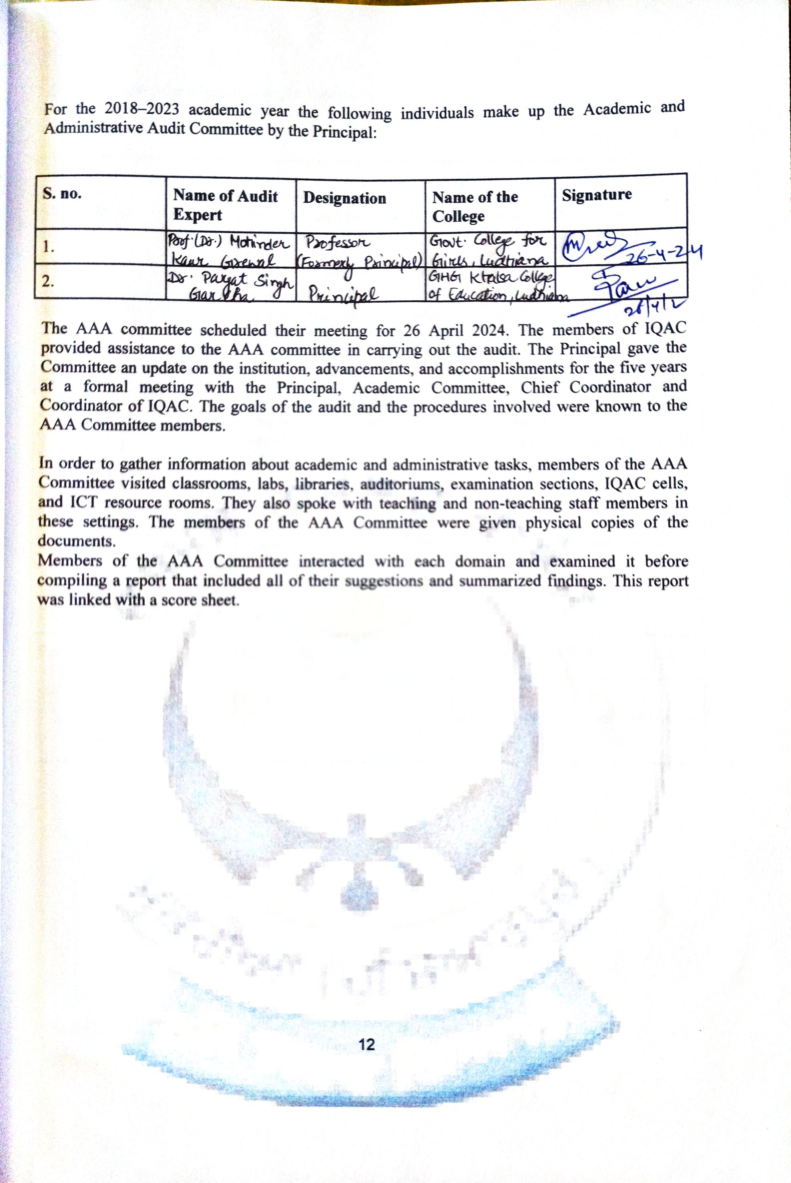

**Academic and Administrative Audit Schedule:**

| **Time** | **Activity** | |
| --- | --- | --- |
| 10:15AM-10:30 AM | **Welcome and briefing by Principal**  **Venue: Conference Room** | Welcome and Briefing by Principal regarding the objectives of the audit.  **Venue: Conference Room** |
| 10:30AM- 12:00PM | **Meeting with IQAC & AAA Team** | * Verification of documents |
| 12:00PM-01:45PM | **Visit to classrooms and laboratories, Library, Departments and Administrative Office** | * Meeting with the faculty members * Visit to the facilities in the classrooms and labs, any other facility related to advance learning. * Report preparation. * Interaction with the In-charges. |
| 2:00PM to 2:30PM | **Lunch** | Lunch |
| Post Lunch | **Report Preparation** | College Report Writing |
| **Exit** | Exit Meeting with Principal, IQAC Coordinator and Criteria In-charges |



**Report of AAA Committee:**

**Document Verification**

| **Category** | **Description** | **Available** |
| --- | --- | --- |
| **Approval / Accreditations / Awards** | NCTE Approval | Yes/No |
| Affiliation by Panjab University, Chandigarh | Yes/No |
| Recognition 2(f) &12( B)) |  |
| Regd. Certificate of Trust | Yes/No |
| NAAC Certificate | Yes/No |
| AISHE Certificate | Yes/No |
| Awards | Yes/No |
| **Governance** | Governing Body | Yes/No |
| Advisory Committee | Yes/No |
| Academic Committee | Yes/No |
| Internal Quality Assurance Cell | Yes/No |
| Anti Ragging cum Grievance Redressal Cell | Yes/No |
| Internal Complaint Committee for Sexual Harassment for Women | Yes/No |
| Alumni Association | Yes/No |
| Personal Files of Faculty Members | Yes/No |
| Scholarships/Incentives/Fees concession committee | Yes/No |
| Examination Committee | Yes/No |
| Student Council | Yes/No |
| Institution Website | Yes/No |
| Biometric Attendance System | Yes/No |
| Notice Board | Yes/No |
| **Other Facilities** | CCTV Security | Yes/No |
| Projector in Classroom | Yes/No |
| Fire Extinguisher | Yes/No |
| Health Centre | Yes/No |
| Canteen Facility | Yes/No |
| Sport Facility | Yes/No |
| Vehicle Parking | Yes/No |
| Xerox Facility | Yes/No |
| Backup Electric Supply | Yes/No |
| Transport Facility | Yes/No |
| Drinking Water Facility | Yes/No |
| Solid Waste Management | Yes/No |
| E- Waste Management | Yes/No |
| RainWater Storage | Yes/No |
| Green Campus Initiatives | Yes/No |

|  |  |  |  |  |  |  |
| --- | --- | --- | --- | --- | --- | --- |
| **ACADEMIC AUDIT-REPORT** | | | | | | |
| **Name of the College:** Dasmesh Girls College, Chak Alla Baksh, G.T. Road, Mukerian | | | | | | |
| **Audit Team** | | | | | | |
| 1 | Prof. (Dr.) Mohinder Kaur Grewal (Former Principal Govt. College for Girls Ludhiana, Director S. Govt. College of Science Education and Research, Jagraon) | | | | | |
| 2 | Dr. Pargat Singh Garcha (Principal GHG Khalsa College of Education, Gurusar Sudhar, Ludhiana) | | | | | |
| **Date of Audit:** 26 April, 2024 | | | | | | |
|  | | | | | **Observations** | **Remarks/Suggestions** |
| **College Timings**  **9: 00 am- 3:00 pm** | | | | |  |  |
| **I. Curricular Aspects** | | | | |  | . |
| 1. | | **Session Courses offered Strength** | | |
|  | | 2018-19 | 15 | 1277 | New Courses have been introduced after 1st Cycle of NAAC. | Good |
|  | | 2019-20 | 16 | 1236 |
|  | | 2020-21 | 16 | 1240 |
|  | | 2021-22 | 18 | 1273 |
|  | | 2022-23 | 18 | 1238 |

|  |  |  |  |
| --- | --- | --- | --- |
| 2. | Add-on/Certificate Courses | Add on Courses have been introduced | Work on to increase the  No. of add-on/Certificate Courses. |
| 3. | Annual Curricular Plan | Academic Calendar | Good |
| 4. | Attendance | Records Maintained | Good |
| 5. | Stakeholders’ Feedback | Record of five stakeholders maintained | Good |
| **II. Teaching- Learning and Evaluation** | |  |  |
| 1. | No. of Full time Teacher  Adhoc/ Part time Faculty | Data Available  64 Teachers | Satisfactory as per the strength of the students |
| 2. | Student Enrolment and Profile | 76.6% | More efforts should be done |
| 3. | Teaching-Learning Process:  Student seminars  Remedial Classes  Student Assignment | Records Maintained | Good |
| 4. | Teacher Profile and Quality | Records compiled | Good |
| 5. | Evaluation Process and Reforms | Proper Evaluation Procedure is implemented | Good |
| 6. | Student Performance and  Learning Outcomes | Institutional based assessment of learning outcomes system is used | OBE can be explored |
| 7. | Student Satisfactory Survey | Good | Good |

|  |  |  |  |
| --- | --- | --- | --- |
| **III. Research, Innovation and Extension** | |  |  |
| 1. | Innovation Ecosystem | Efforts are made to work on the ecosystem | Proper policy can be made regarding this. |
| 2. | Research Publication | Teacher publications  Journal- 47  Edited Books/Chapter in Books-6/68 | More efforts should be made to increase the no. and quality of publication. |
| 3. | Extension Activities | Good no. of extension activities have been organized every year. | Good |

|  |  |  |  |
| --- | --- | --- | --- |
| **IV. Infrastructure and Learning Resources** | |  |  |
| 1. | Physical Facilities (Classroom, Labs, Gymnasium etc.) | Classrooms- 46  Labs-20  Provisions should be made for Dept. of Physical Education & Library at ground floor | Satisfactory as per the perspective plan. |
| 2. | Library | Sufficient Books, Journals, E-journals, E-books are available. | Footfalls can be maximized |
| 3. | IT Infrastructure | 84 Computers  20 Labs (overall) | Good |

|  |  |  |  |
| --- | --- | --- | --- |
| **V. Student Support and Progression** | |  |  |
| 1. | Scholarship/ Fee Concession | Govt./Institutional/ Other Agencies | Alumni Fund should be created and should be used for the students fee and scholarships. |
| 2. | Student Support/ Progression | Data is available. | More efforts should be made to collect the data of placed students. |
| 3. | Student Participation and Activity/ Alumni | Yes, One formal meeting in the year | Good, but Alumni should be registered. |
| VI. **Governance,** **Leadership and Management** | | | |
| 1. | Institution Vision Leadership | Institution is decentralized | Good |
| 2. | Faculty Empowerment Strategies | Welfare schemes | Seed Money/Financial support to faculty |
| 3. | Financial Management | Funds are generated | ERP should be done. |

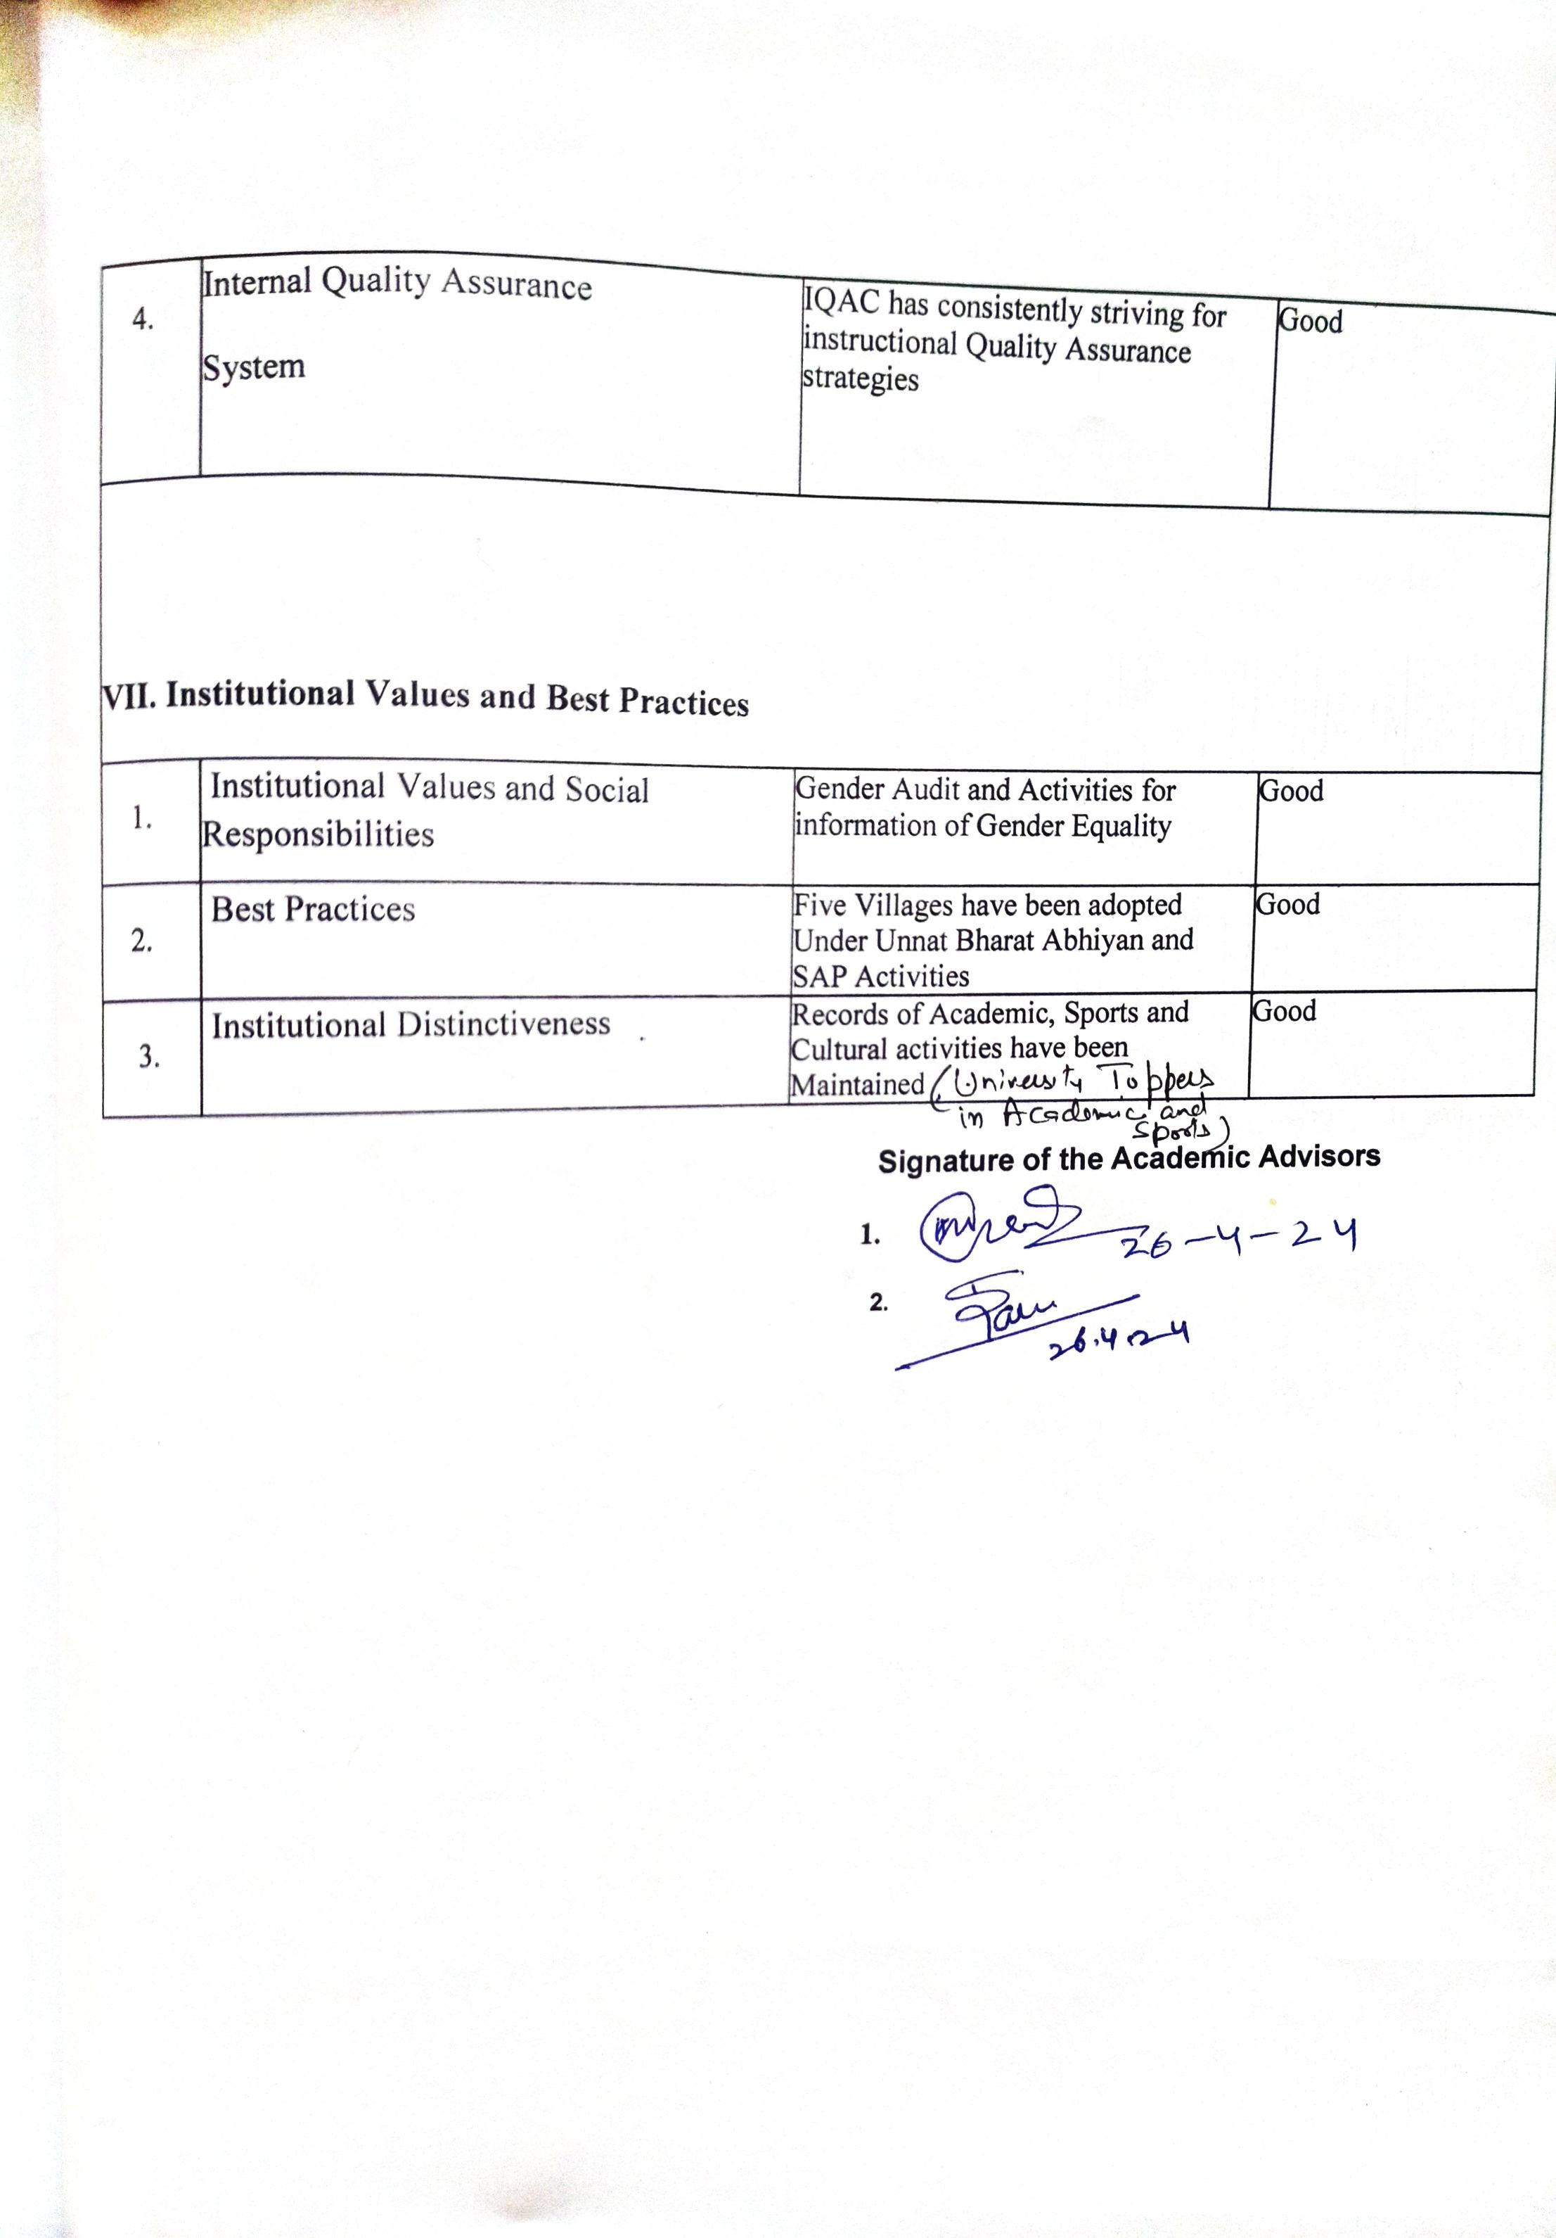

**Glimpses of AAA Committee Visit**

